***Q1: What is the Commercial Distributor/ Managed Reseller Channel Incentives Platform?***A: The Microsoft FY12 Channel Incentives for Commercial Distributors and Managed Resellers (herein called “Partners”) include both cash rebates and Cooperative Marketing Funds (Coop). The Coop program provides funds to participating Distributors to help differentiate and build channel preference and awareness for Microsoft products through increased demand generation, market development, and readiness activities.The Channel Incentives Platform (CHIP) launched in FY11 for Commercial Distributors to create a common interface for all Commercial incentive programs. In FY12, Managed Resellers were onboarded onto CHIP. The system functionality will increase transparency to participating Partners by providing an instant snapshot of available program funds to conveniently view and allow online submission of program documentation. Participating Partners will use the online Channel Incentives Platform system to upload their Marketing Activity requests and POEs (Proof of Executions).

***Q2: What are the benefits to the Partners?***

A:

* **Transparency:** Snapshot of program funds, financial predictability, and reporting and analytics
* **Simplicity:** Single destination to improve business planning and execution, common platform to enhance user experience, and streamlined tools and automated program processes
* **Engagement:** Consistent experience, self-service capabilities, timely payments

***Q3: How is a Partner measured and paid?***

A: Partners earn incentives on eligible revenue, based on both globally-defined objectives and locally-defined accelerators

according to the percentage of revenue they perform in each category based on their purchases from Microsoft. Earned incentives are paid to partners as Cash Rebates and Coop Marketing Funds. At the end of a six-month Accrual Period, Partners

are credited with rebates, and start to claim Coop Funds.

Diagram: Disti Co-Op Earning and Usage Periods

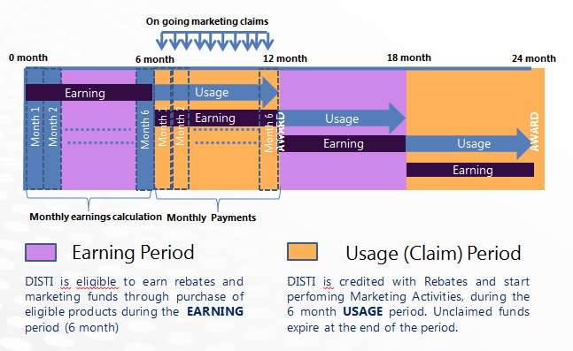

***Q4: Who in my organization is able to submit Marketing Activities through the platform and how do we know geographically where the activities apply?***

A: Any individual in the Partner organisation can submit a Marketing Activity request as long as they have been granted proper permissions from the Channel Incentive “Partner Administrator” at the Distributor or Managed Reseller. Once the activity has been submitted, then a POE (Proof of Execution) may be uploaded.

***Q5: What user roles are available on the Channel Incentives Platform and what are their responsibilities?***

A: **Partner Administrator**  - Full Access with Administrative Privileges to Add/Delete Users (Limit 3)

**Partner Program User** - Ability to Submit Marketing Activities and POE

**Partner Read-Only User** - Limited Access/Read-Only Privileges

Anyone who is set up as a Partner Admin or Partner User will be able to enter data into the Channel Incentives Platform. If you have any other questions regarding Channel Incentive Platform System, please email to [chiphelp@microsoft.com](mailto:chiphelp@microsoft.com)

***Q6: How do I get access to the Channel Incentives Platform?***

A: Potential users will need to contact the designated Partner’s Program Administrator for their account.

***Q7: How do I log into the Channel Incentives Platform? Why do I need a Windows Live ID?***

A: Once the designated Partner Program Admin has added users into the system, they will be able to access the platform by using a Windows Live ID. Along with the majority of Partner facing systems, the Channel Incentives Platform uses Windows Live ID to authentic users. The use of Windows Live ID reduces and simplifies the number of log-ins that Partner’s need to remember in order to access Microsoft tools.

***Q8: How can I learn how to use the Channel Incentives Platform?***

A: A copy of the presentation of the Channel Incentives Platform training session can be requested from the Microsoft Partner Account Manager or Operations Account Manager.

Notice: The information contained in this FAQ is Microsoft Confidential. This FAQ is an overview and is intended to be utilized for informational purposes only. Microsoft makes no warranties, express or implied, in this FAQ. Nothing in this FAQ modifies any of the terms and conditions of Microsoft’s written and signed agreements. This in not an offer and this FAQ may be changed at any time by Microsoft.